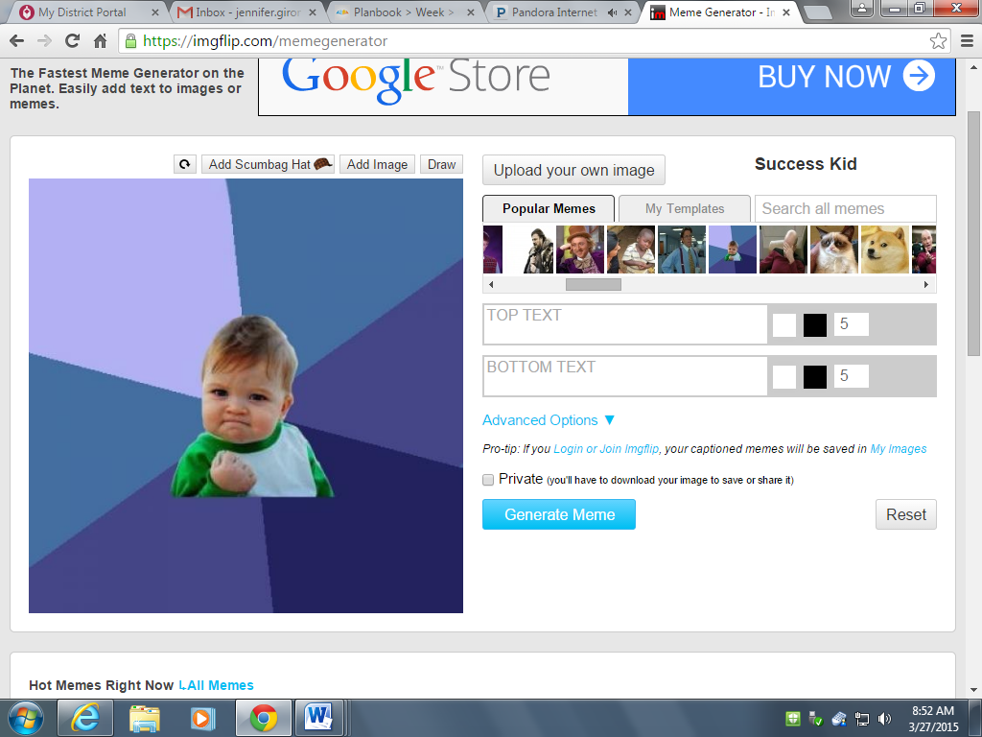

YOUR WORK IS IN THE KILN. RIGHT NOW.

WIN!