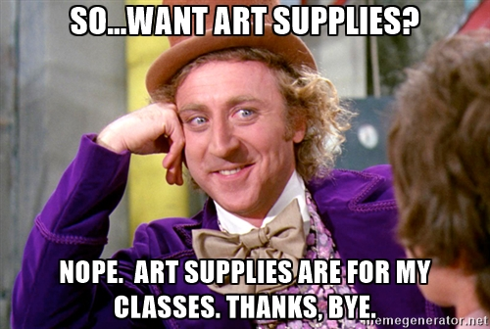

PLEASE DO NOT INTERUPT MY CLASSES/PLANNING.

